(0.0 Miles) Starting from the overflow carpark go down the access road bearing left at the junction after 100 metres. After another 50 metres bear right across the grass.
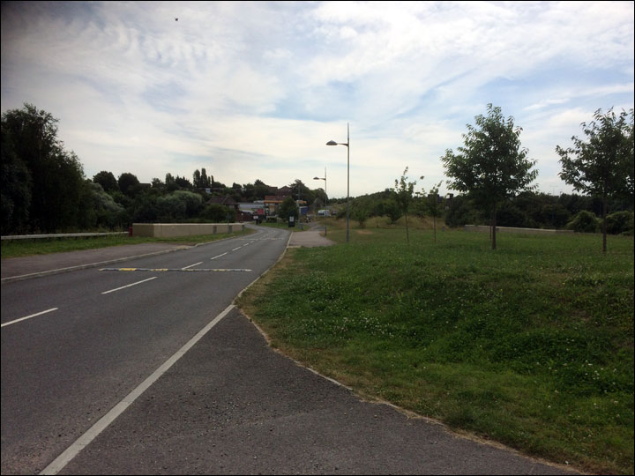Straight up the grassy edge here on to the tarmac path in the centre of the photo
Do not cross the road. After 30 meters join tarmac cycle path. You are now going on a straight line for the next 0.9 miles along cycle path 177 up the incline ahead of you. You’ll pass a garage on your left after about 200 metres.
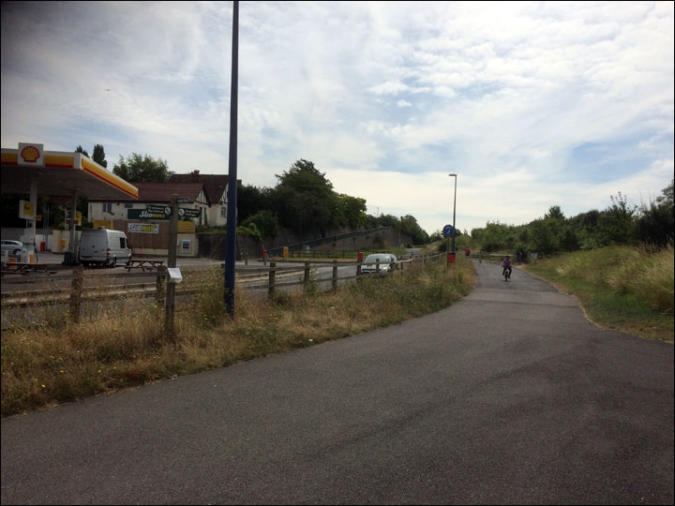
Go through the gate and bear left just past the garage on the path running alongside a high wall.
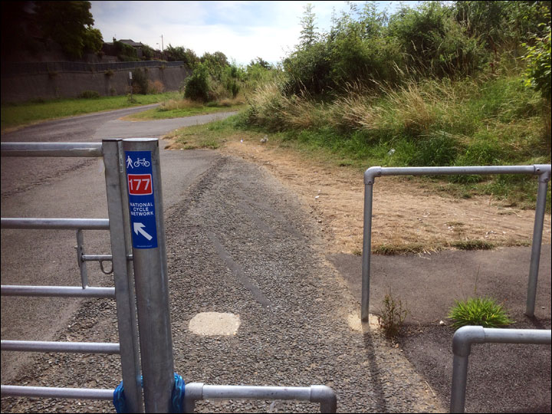Head up the path by the high wall, you’re following Cycle Path 177
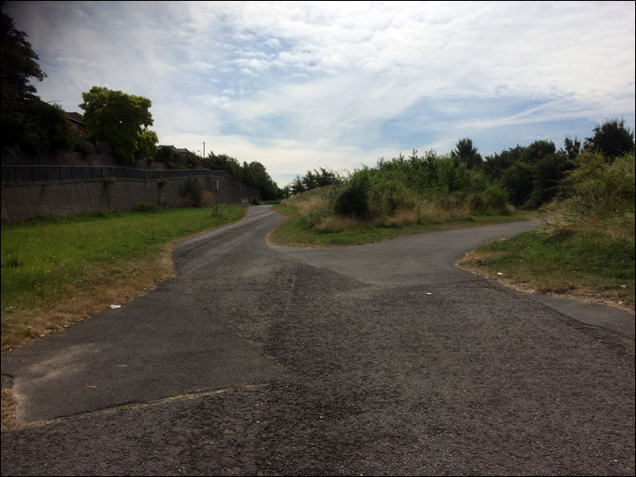Take the path by the high wall.
Ignore paths to the left and right.

(1.1 Miles) Opposite the Premier Inn is the “Rabbit Bridge”. Bear right up onto the access path just before you reach the hotel opposite Singlewell Car Sales and cross over the bridge passing over the A2(M) and railway lines. Follow the path until you meet Church Road. Turn left onto grassy/gravelly path up the hill. Do not run on the road but stay on the path that runs parallel with it. After approx 0.5 miles, you will reach a road junction, cross with care and turn right on the pavement. After 100 metres turn left into the entrance of Jeskyns Park and follow round the carpark to the left for 100 metres (toilets are situated in the café to the right of the carpark) and go through the kissing gate onto a wide gravel path a few feet afterwards you’ll pass a “Welcome to Jeskyns” sign.
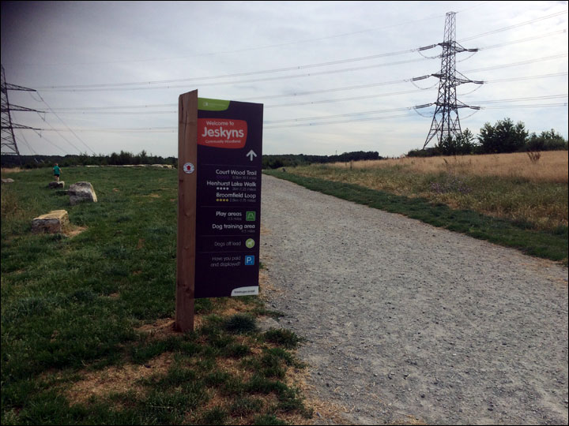

(2.0 Miles) After 50 metres on your left you will see a small wall structure. Pass this and continue along the wide path for approx 400m downhill and turn left downhill by a bench and bin onto a similar well-made gravel path that has a hedge on your right.
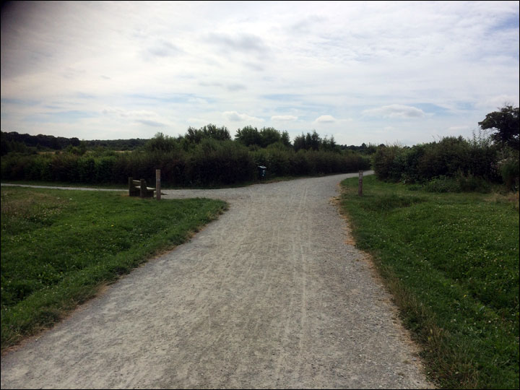
Turn left here
Follow this gravel path for approx 700m as it bears right passing between two grassy meadows and then passes through two wooden sculptures.
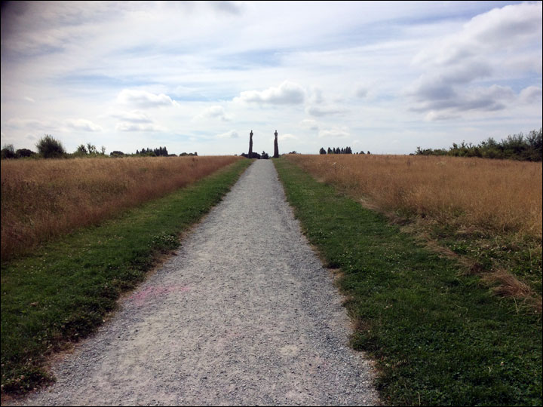
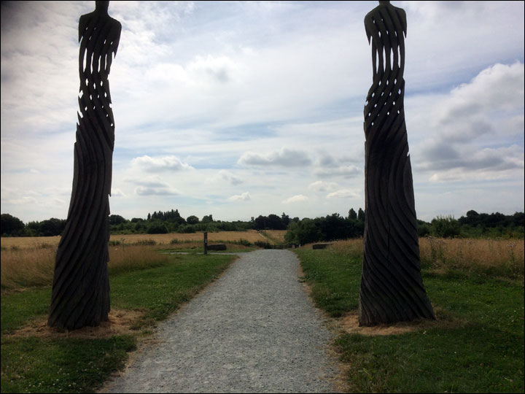When you reach a complex junction go through the gates and continue on line of travel onto a grassy path up a slight incline (ignore the gravel paths/farm track). 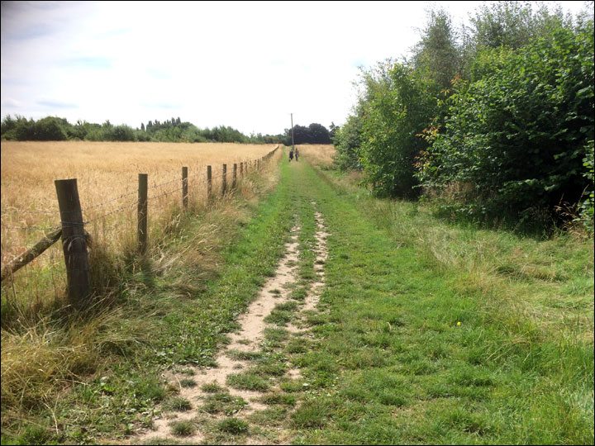

After 300m pass through a kissing gate and turn right onto a rough dirt road under trees.

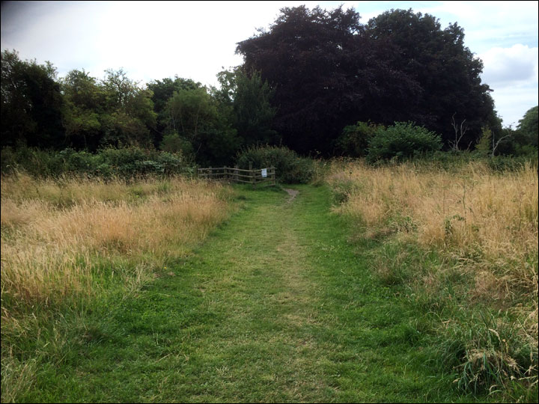After 50m turn right onto Battle Street.

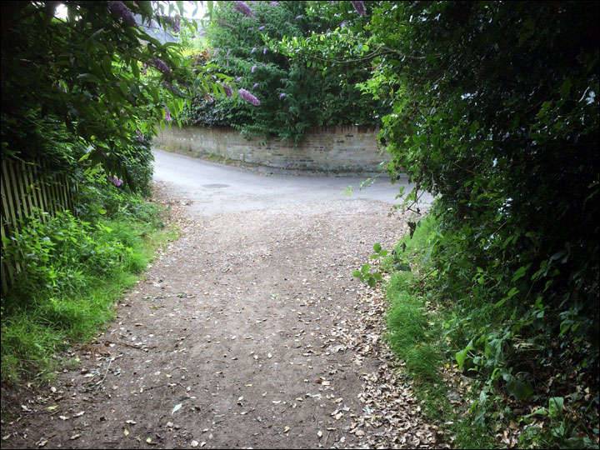
Turn right here in to Battle Street

After 250m you will reach Cobham High Street, cross the road with care and turn left.
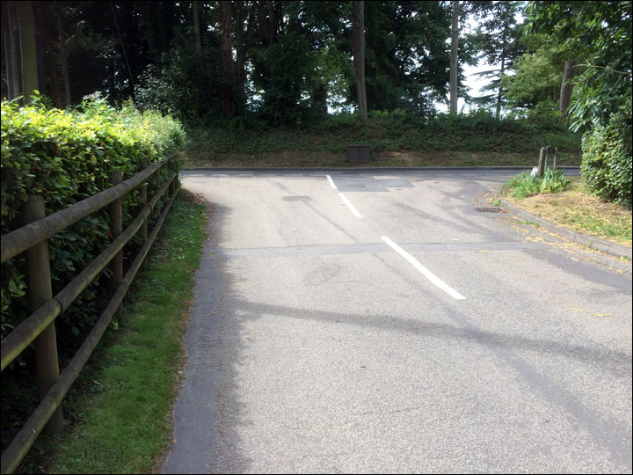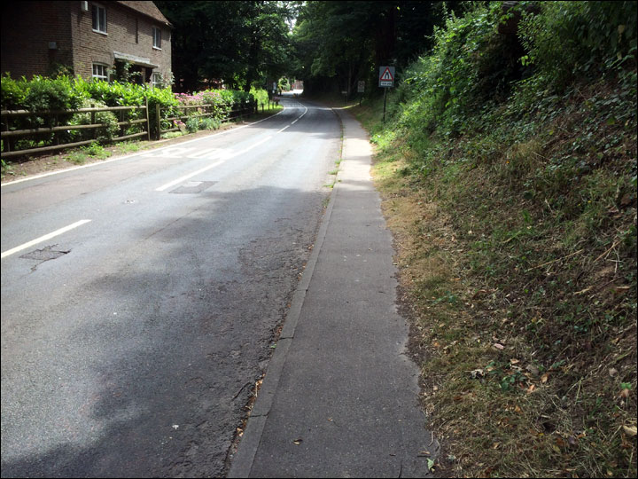You are now heading up Cobham High Street till it runs out, take care crossing roads!

(3.1 Miles) You are now basically going to continue on a straight line for approx 2.5 miles. En route you will pass The Leather Bottle pub on your left, the Church on your right and The Ship Inn on your left. Cross the road at the War Memorial (TAKE CARE!) and continue on the same line of travel up a small country lane (Lodge Lane). Cross the junction with care. After 400m you will pass a few houses and a farm on the right, continue on same line of travel. At the White Thatched Cottage where the road bends right continue straight on the line you have been travelling, go through the kissing gate and past the National Trust sign on to a wide gravel path.
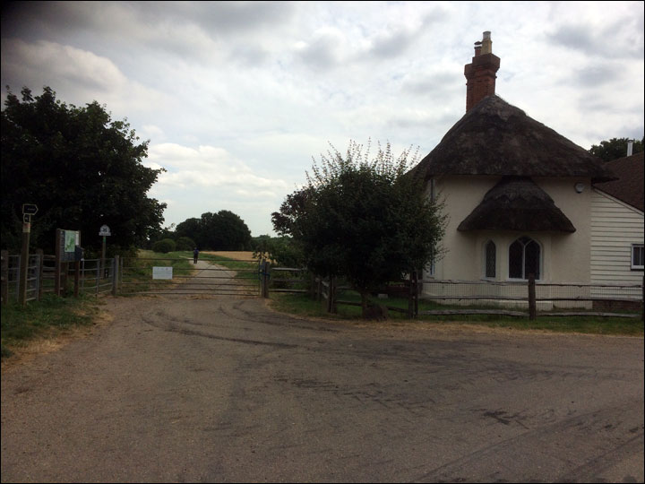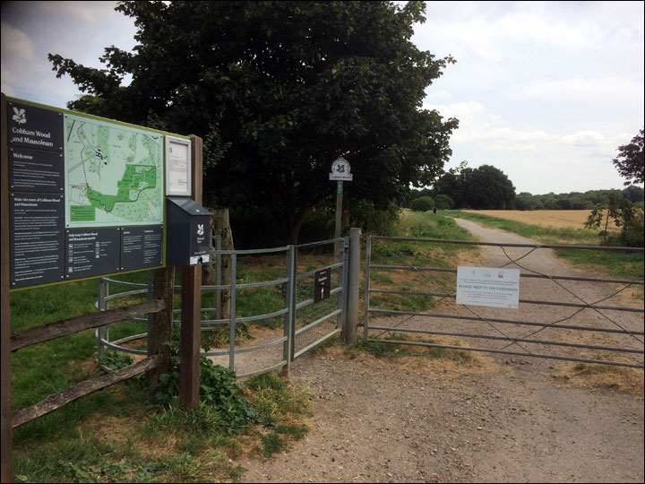

(4.2 Miles) After 500m go through another gate passing another NT sign and after a further 700m pass the Darnley Mausoleum on your right. Continue along the narrower trail entering Ranscombe Farm Reserve through a kissing gate. Follow along the wide trail that goes downhill ignoring all paths left and right. After approx 1 mile you will come to a small grassy area in front of a footbridge over the high speed railway, bear right along a small path alongside the wire fence. Do NOT cross the railway line footbridge.

(5.8 Miles) Follow this narrow path in a straight line for approx 0.5miles. The high speed rail link will be to your left and a wire fence. After descending several rough steps turn right down a narrow overgrown path. After 100m enter a crop field and continue on same line of travel up the path for 300m before emerging on the farm road.

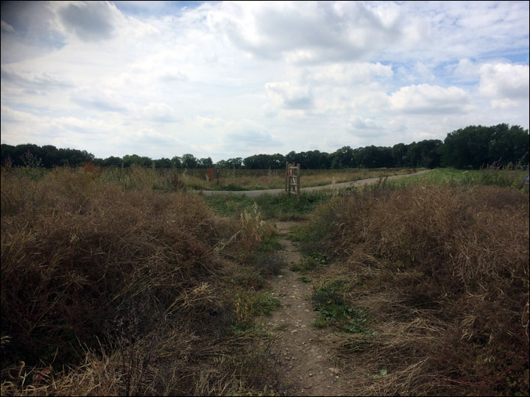
Cross the farm road and continue along same line of travel along a farm track for 200m until you reach the aid station.

(7.0 Miles) Continue past the aid station on the farm track that turns in to a path.
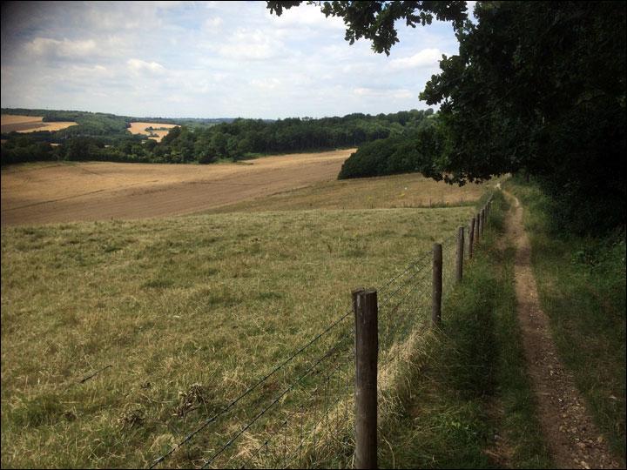After 500m you will enter another crop field. After 150m at the waist high waymarked path junction turn right. Do NOT go up the hill.
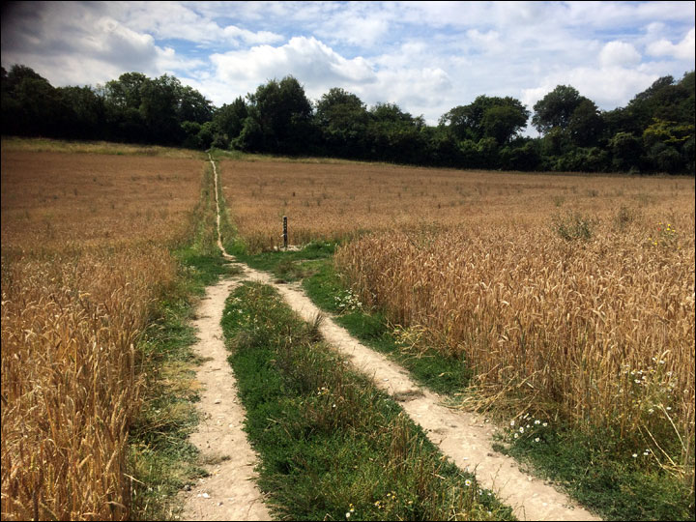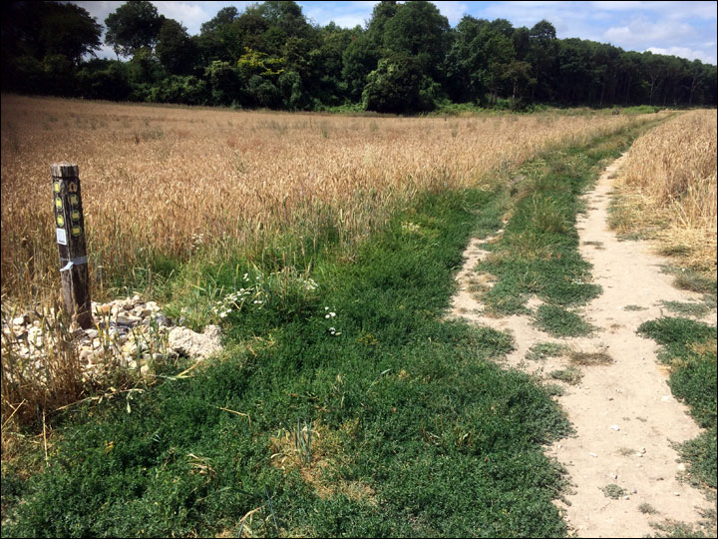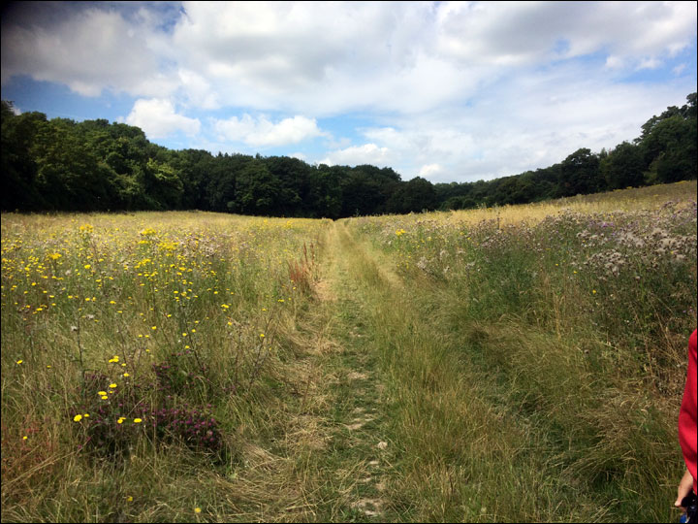
Go through the field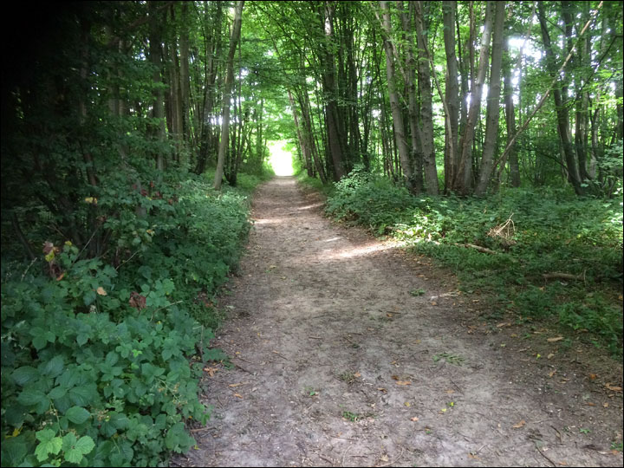
And on through the wood.
Follow this path across for 600 metres of field till you reach a small wooded area, continue straight through the wood (150 metres) and then a kissing gate, into another field and then after another 100 metres turn right at the waist high waymarked junction uphill towards a gate into wood.

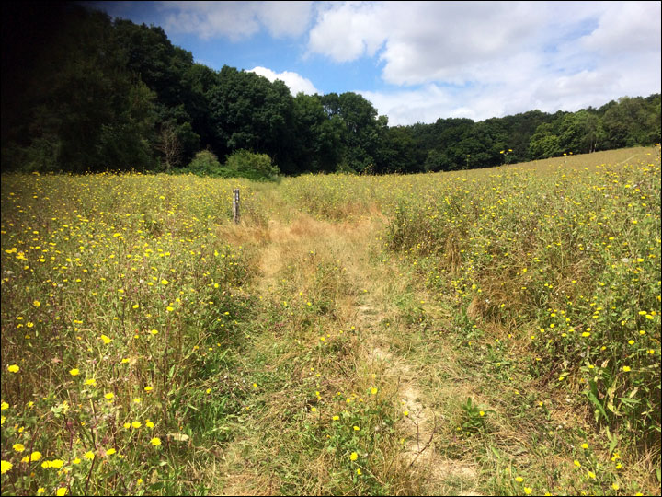Turn right at this marker up the hill
Go through the gate posts passing the bench and bear left uphill to the gate. Follow the narrow path through the woods uphill for approx 300m and then turn left on main path. (From this point onwards you are now retracing your steps back to the start). After approx. 100m go through gate in to Cobham Wood.

(8.1 Miles) After 350m you will pass Darnley Mausoleum on your left. Proceed along the same line of travel, through a kissing gate until you reach the final kissing gate at the exit of the National Trust land.
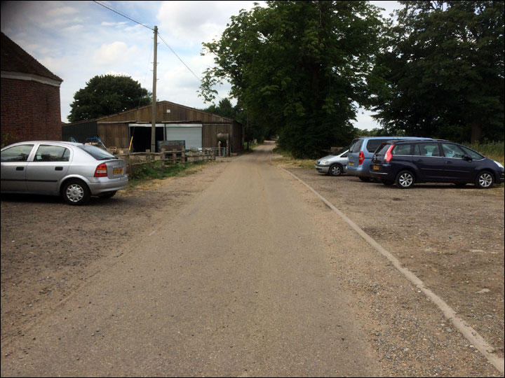Passing the White Thatched Cottage, farm and more cottages on a narrow country lane (Lodge Lane) until you reach the War Memorial at the junction with Cobham High Street.

Cross the junction with care and proceed in the same direction of travel along the High Street passing The Ship Inn, Church and Leather Bottle Public House.

(10.1 Miles) 200m past the Leather Bottle Public House turn right into Battle Street taking care crossing the road. After 250m bear left at the end of the road along a rough road

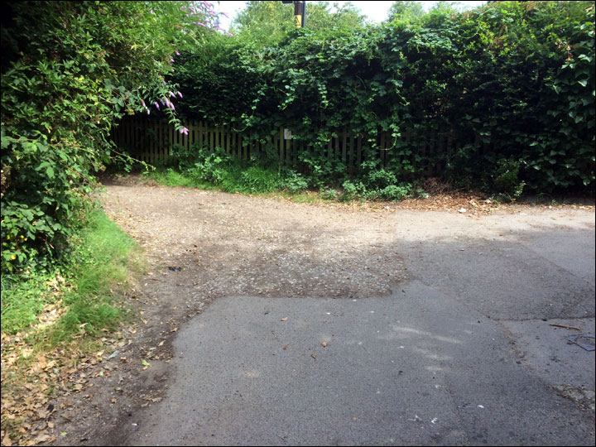then after 50m turn left through kissing gate.

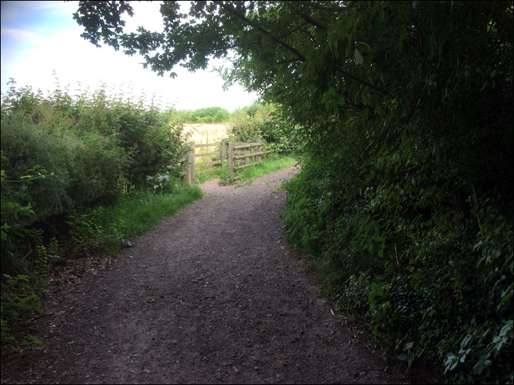

Follow path for 300m down incline to a complex junction.

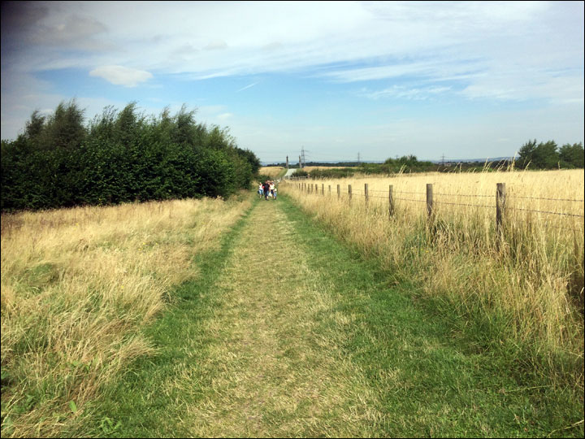Go through gates into Jeskyns and continue on same line of travel passing between two tall wooden sculptures.

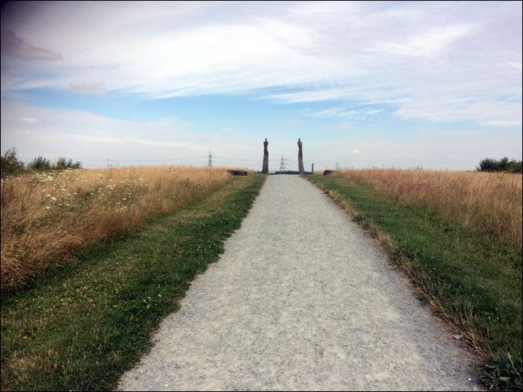Up the hill through the wooden sculptures

Stay on gravel path for 600m bearing left with the path up an incline, and then turning right onto another gravel path at a T junction with bench and bin.

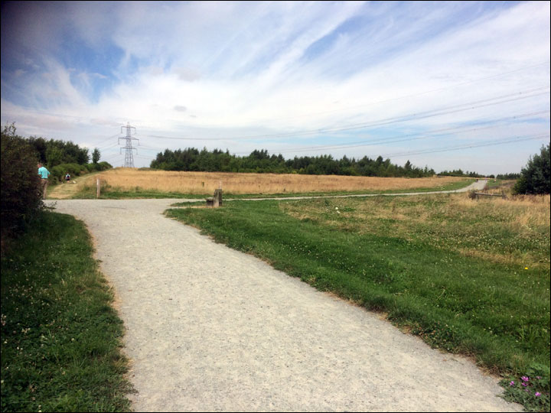
Turn right here

Follow this for 350m when you will reach the carpark, go through the kissing gate, bear right around the carpark (watch out for traffic!) and follow round to Jeskyns exit. (Toilets are available in the cafe to the left of the carpark) From the exit, turn right on to the pavement and after 100m (just before the road crosses the railway line) turn left into Church Road taking care as you cross.

(11.3 Miles) Follow grassy/gravelly verge path down Church Road for 0.5mile turning right as the path ends onto the narrow footpath (signposted) and continue along crossing the railway line and A2(M) over the Rabbit Bridge.

(11.9 Miles) Bear left at the end of the bridge, following the path down to meet the wide tarmac cycle path 177. Follow the cycle path in a straight line for approx 0.9mile passing a garage on your right at the bottom of the hill, through the gate and carry on into the Cyclopark Complex

(12.9 miles) Cross the short grassy area and bear left up the gravel road to the overflow carpark and race HQ in Cyclopark.

Well done - you have completed 13.1 miles.

